Day 3: DNS Server Configuration

1. Learning Objectives
By the end of this session, students will be able to:
- Understand DNS and its importance in networking.
- Explain how DNS converts domain names into IP addresses.
- Understand DNS servers and DNS records.
- Configure a DNS server in Cisco Packet Tracer.
- Configure client computers to use a DNS server.
- Test domain name resolution using nslookup and ping.
- Identify and troubleshoot common DNS problems.

Part A: Theory (30 Minutes)

2. What is DNS?
DNS stands for Domain Name System.
DNS is a network service that converts human-readable domain names into IP addresses.
Computers communicate with each other using IP addresses, but humans find it easier to remember website names instead of numerical IP addresses.
DNS works like a phonebook for the internet.
Real-time example:
Suppose you want to open Google's website.
You enter:
www.google.com
Your computer needs the IP address associated with that domain to connect to the correct server.
DNS helps find that IP address.
For example:
Domain Name: www.example.com
IP Address: 93.184.216.34
The IP address above is an illustrative example.

3. Why Do We Need DNS?
Imagine a company has 100 computers and multiple internal servers.
Employees need to access different services, such as:
- Employee management system
- Attendance system
- File server
- Company website
- Email server
Remembering the IP address of every server is difficult.
Instead, DNS allows employees to access services using domain names.
Example:
attendance.company.local
files.company.local
hr.company.local
Benefits of DNS:
- Easy access to websites and servers.
- Reduces the need to remember IP addresses.
- Makes network management easier.
- Supports name resolution for internal networks.
- Allows administrators to change server IP addresses while keeping domain names consistent, provided DNS records are updated.

4. How Does DNS Work?

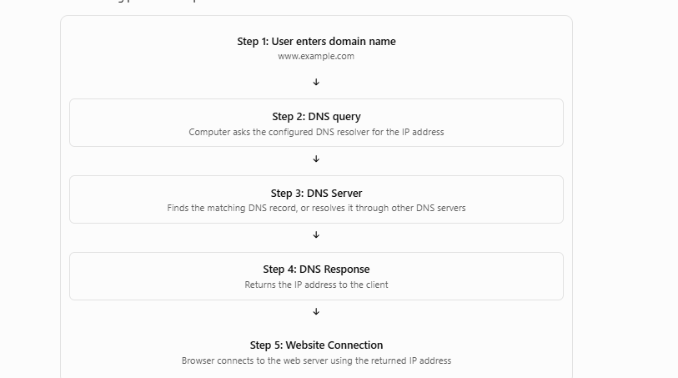
Let's understand the process step by step.
Suppose a student enters:
www.example.com
in a web browser.
The following process takes place:
Step 1: User enters domain name
www.example.com
Step 2: DNS query
Computer asks the configured DNS resolver for the IP address
Step 3: DNS Server
Finds the matching DNS record, or resolves it through other DNS servers
Step 4: DNS Response
Returns the IP address to the client
Step 5: Website Connection
Browser connects to the web server using the returned IP address

Detailed Explanation
Step 1: User Request
The user enters a website name in the browser.
Example:
www.amazon.com
Step 2: DNS Query
The computer checks its DNS cache. If it does not have a usable cached answer, it sends a DNS query to its configured DNS resolver.
Step 3: DNS Resolution
If the resolver does not already have the answer cached, it may contact different DNS servers.
The main DNS server hierarchy includes:
- Root DNS Server
- TLD DNS Server
- Authoritative DNS Server
Step 4: DNS Response
The resolver returns the required IP address to the computer.
Step 5: Website Connection
The browser uses the returned IP address to connect to the website server.
Important: DNS resolution and website communication are two different processes. DNS finds the destination address; HTTP or HTTPS handles web communication.

5. Types of DNS Servers
There are different types of DNS servers.

A. DNS Resolver
A DNS resolver receives DNS queries from client devices and finds the requested DNS information.
Example: A computer uses its configured DNS resolver to find the IP address of Google.

B. Root DNS Server
The root DNS server helps direct DNS queries toward the correct Top-Level Domain (TLD) servers.

C. TLD DNS Server
TLD stands for Top-Level Domain.
It helps identify the authoritative DNS servers for a particular domain extension.
Examples:
- .com
- .org
- .in
- .net

D. Authoritative DNS Server
An authoritative DNS server stores the actual DNS records for a domain and provides authoritative answers for that domain.
Example: It may contain the IP address associated with www.example.com.

6. Types of DNS Records
DNS uses different records to store domain-related information.
DNS Record | Purpose | Example
A | Maps a domain to an IPv4 address | example.com → 192.168.1.10
AAAA | Maps a domain to an IPv6 address | example.com → 2001:DB8::10
CNAME | Creates an alias for another domain name | www → example.com
MX | Identifies mail servers for a domain | mail.example.com
NS | Identifies authoritative name servers | ns1.example.com
PTR | Maps an IP address to a domain name | Reverse DNS lookup
TXT | Stores text information | Domain verification

Easy Real-time Examples
A Record: A company website points to an IPv4 address.
AAAA Record: A website points to an IPv6 address.
CNAME Record: www.company.com is an alias of company.com.
MX Record: Helps email servers identify where to deliver emails for a domain.
TXT Record: Used for domain ownership verification and email security policies.

7. DNS Port Numbers
Protocol | Port | Purpose
UDP | 53 | Most standard DNS queries and responses
TCP | 53 | DNS zone transfers and DNS communication requiring TCP
DNS generally uses UDP port 53 for normal queries, but TCP port 53 is also important.

8. DNS Caching
DNS caching means temporarily storing DNS responses so the computer does not need to perform a fresh DNS lookup every time it accesses the same domain.
Real-time example:
- First time: You open www.example.com.
- DNS resolution takes place.
- The result is cached.
- Next time: Your computer may use the cached result.
Benefits:
- Faster DNS resolution.
- Reduces unnecessary DNS queries.
- Reduces DNS server workload.
The time for which a DNS record can be cached is controlled by its TTL (Time To Live).

Part B: Practical (30 Minutes)

Practical: Configure a DNS Server in Cisco Packet Tracer
Hands-on practical
Objective: Configure a DNS server, create a domain name record, connect client computers, and test domain name resolution.

Requirements
Open Cisco Packet Tracer and add:
- 1 Server (Server-PT)
- 1 Switch (2960)
- 2 PCs (PC0 and PC1)

Step 1: Create Network Topology

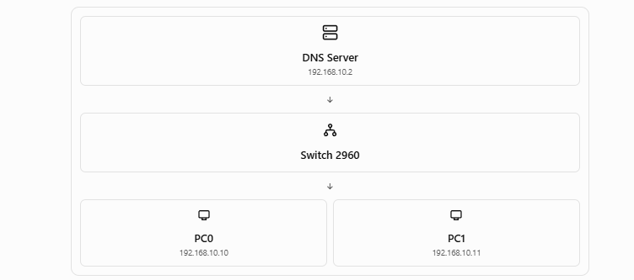
Connect all devices using Copper Straight-Through cables.
DNS Server
192.168.10.2
Switch 2960
PC0
192.168.10.10
PC1
192.168.10.11

Step 2: Configure the DNS Server IP Address
Click Server → Desktop → IP Configuration.
Enter the following details:
Field | Value
IP Address | 192.168.10.2
Subnet Mask | 255.255.255.0
Default Gateway | 192.168.10.1
DNS Server | 192.168.10.2
For this single-LAN practical, a router is not required. The default gateway is only needed if communication with another network is required.

Step 3: Enable DNS Service
Now configure the DNS service.
- Click Server.
- Open the Services tab.
- Select DNS from the left-side menu.
- Switch DNS Service to ON.
You will see the DNS Resource Records section.

Step 4: Create a DNS Record
We will create our own domain name.
Enter the following information:
Field | Value
Name | www.studentlab.com
Type | A Record
Address | 192.168.10.2
Click Add.
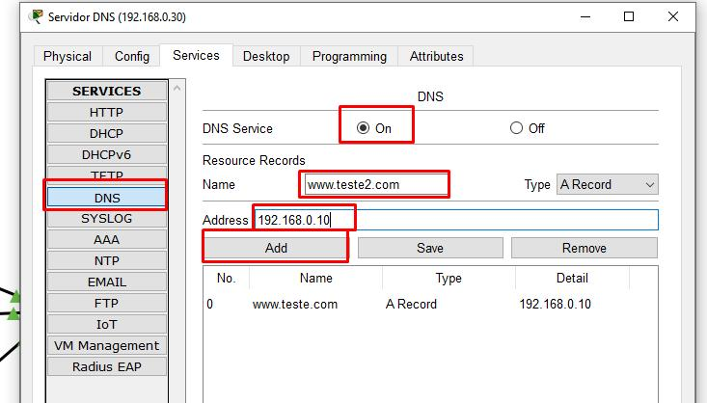
Now the DNS server has the following record:
Domain Name: www.studentlab.com
Record Type: A
IP Address: 192.168.10.2
This means whenever a client asks for the IP address of www.studentlab.com, the DNS server will return 192.168.10.2.

Step 5: Configure PC0
Click PC0 → Desktop → IP Configuration.
Enter:
Field | Value
IP Address | 192.168.10.10
Subnet Mask | 255.255.255.0
Default Gateway | Leave blank
DNS Server | 192.168.10.2

Step 6: Configure PC1
Click PC1 → Desktop → IP Configuration.
Enter:
Field | Value
IP Address | 192.168.10.11
Subnet Mask | 255.255.255.0
Default Gateway | Leave blank
DNS Server | 192.168.10.2
Both PCs will now use the configured DNS server.

Step 7: Test DNS Resolution
Click PC0 → Desktop → Command Prompt.
First, test the DNS server connection:
ping 192.168.10.2
If the connection is successful, test the domain name:
ping www.studentlab.com
Expected result
The domain name should resolve to:
192.168.10.2
The ping should receive replies if the server is reachable and its ICMP service is responding.

Step 8: Test Using Web Browser
We can also test DNS using the Packet Tracer web browser.
First, enable the HTTP service on the server:
- Click Server.
- Open Services.
- Select HTTP.
- Turn HTTP Service ON.
Now click PC0 → Desktop → Web Browser.
Enter:
http://www.studentlab.com
The server's default webpage should open.
This confirms that:
- The DNS record is configured.
- The client can communicate with the DNS server.
- The domain name resolves to the server IP.
- The HTTP service is accessible.
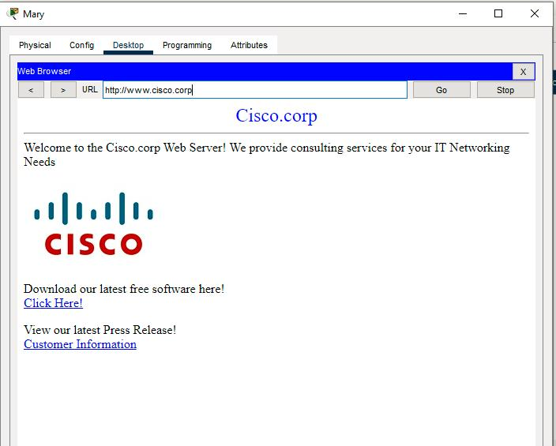
Important: DNS resolution and HTTP service are separate. If DNS works but HTTP is disabled, the domain can resolve successfully but the webpage will not open.

Part C: Additional DNS Practical – Multiple Domain Names
Now give students a small challenge.
Ask them to create three different domain names pointing to different servers.
For this activity, add another server and configure its IP address as 192.168.10.3.

DNS Server Records
On the DNS server (192.168.10.2), create these records:
Domain Name | Type | IP Address
www.studentlab.com | A | 192.168.10.2
www.google.local | A | 192.168.10.3
www.college.local | A | 192.168.10.3
The second server should have HTTP enabled if students need to open its webpage.
Now test from PC0:
ping www.studentlab.com
ping www.google.local
ping www.college.local
Students should observe that different domain names can resolve to the same IP address.
Learning point: DNS allows administrators to create multiple names for different services and servers.

Part D: DNS Troubleshooting

1. Common DNS Problems
Problem | Possible Reason | Solution
Domain name not resolving | DNS service is OFF | Turn DNS service ON
Incorrect IP returned | Wrong DNS record | Check A record
Cannot reach DNS server | Incorrect client configuration or cable | Check IP and connectivity
Domain works on one PC only | Incorrect DNS setting on another PC | Configure correct DNS server IP
Ping IP works but domain fails | DNS configuration issue | Check DNS server and record
Domain resolves but website does not open | HTTP service is OFF | Enable HTTP service
Website opens using IP but not domain | DNS resolution issue | Verify DNS record

2. Useful Troubleshooting Commands
Students should understand these commands.
Command 1: Check IP configuration
ipconfig
Purpose: Displays the computer's IP address, subnet mask, gateway, and DNS configuration.
Command 2: Test DNS server connectivity
ping 192.168.10.2
Purpose: Checks whether the DNS server is reachable.
Command 3: Check domain resolution
nslookup www.studentlab.com
Purpose: Queries the DNS server to find the IP address associated with a domain name.
Note: nslookup support depends on the Packet Tracer PC command-line version. If unavailable, use the ping hostname test and Simulation Mode to observe DNS packets.
Command 4: Clear Windows DNS cache
ipconfig /flushdns
Purpose: Clears the local DNS resolver cache on a real Windows computer.
Command 5: Check DNS cache
ipconfig /displaydns
Purpose: Displays cached DNS records on a real Windows computer.
The last two commands are for actual Windows systems; Packet Tracer's simulated PC may not support them.

3. Advanced Troubleshooting Activity
Give students this situation:
Problem: PC0 can ping 192.168.10.2, but it cannot access www.studentlab.com.
Ask students to identify the possible issue.
Expected troubleshooting steps:
- Check whether DNS service is ON.
- Verify the domain name spelling.
- Verify the A record.
- Check whether PC0 has the correct DNS server address.
- Try pinging the domain again.
- Verify that the DNS server is reachable.

Part E: Student Assignment

Task: Document DNS Configuration and Troubleshooting Steps
Students must prepare a practical report covering the following topics:
Theory:
- What is DNS?
- Why do we need DNS?
- Explain how DNS resolves a domain name into an IP address.
- Explain Root, TLD, and Authoritative DNS servers.
- Explain A, AAAA, CNAME, MX, and NS records.
- What is DNS caching?
- Which port does DNS use?
Practical:
- Create the Packet Tracer topology.
- Configure the DNS server IP address.
- Enable DNS service.
- Create at least three DNS records.
- Configure client DNS settings.
- Test domain resolution.
- Test the website using a web browser.
- Identify and resolve at least two DNS configuration problems.
Submission Requirements:
- Packet Tracer topology screenshot.
- DNS server IP configuration screenshot.
- DNS service and records screenshot.
- PC IP configuration screenshot.
- Successful domain resolution screenshot.
- Troubleshooting steps and solutions.
- Save the Packet Tracer file as Day3_DNS_Configuration.pkt.

End-of-Day Quick Revision
Question | Answer
What is DNS? | Domain Name System
What is the purpose of DNS? | Converts domain names into IP addresses
Which port does DNS use? | 53
What is an A record? | Maps a domain to an IPv4 address
What is an AAAA record? | Maps a domain to an IPv6 address
What is an MX record? | Identifies mail servers
What is a CNAME record? | Creates a domain alias
What is DNS caching? | Temporarily stores DNS results
Which command checks DNS resolution? | nslookup
Which command tests connectivity? | ping
Expected Learning Outcome: Students should understand DNS resolution, configure a DNS server in Cisco Packet Tracer, create domain records, test domain resolution, access a website using its domain name, and troubleshoot common DNS problems.
Trainer suggestion: At the end, ask students: "If you can open a website using its IP address but cannot open it using its domain name, what could be the problem?" This question will help them understand the actual role of DNS in networking.

